LESSON FOUR 地图练习
一. 读题，并回答问题。
1题目主题是什么？全文用什么时态？
2概述思路是什么？
3文章主体如何分段？
4每段选择哪些要点？按什么顺序描述？
You should spend about 20 minutes on this task.
The maps below show the site of a school in 2004 and the plan for changes to the school site in 2024.
Summarise the information by selecting and reporting the main features, and make comparisons where relevant.
Write at least 150 words.
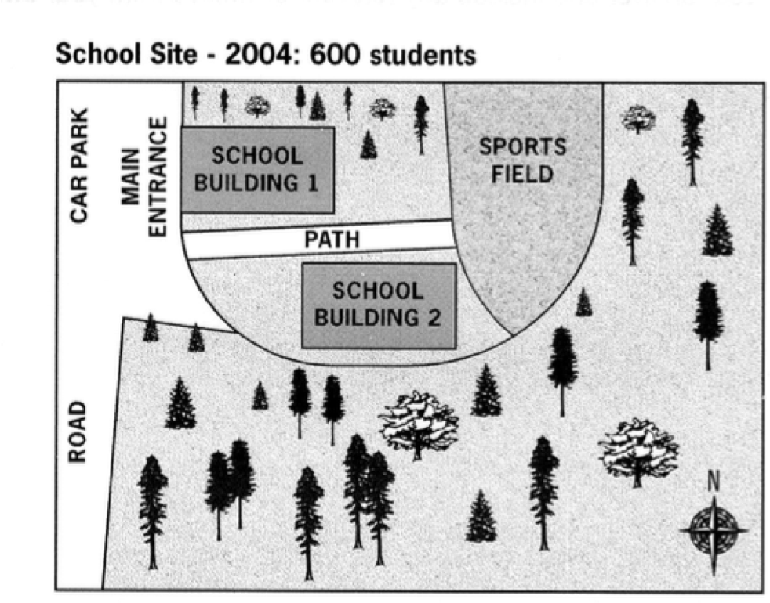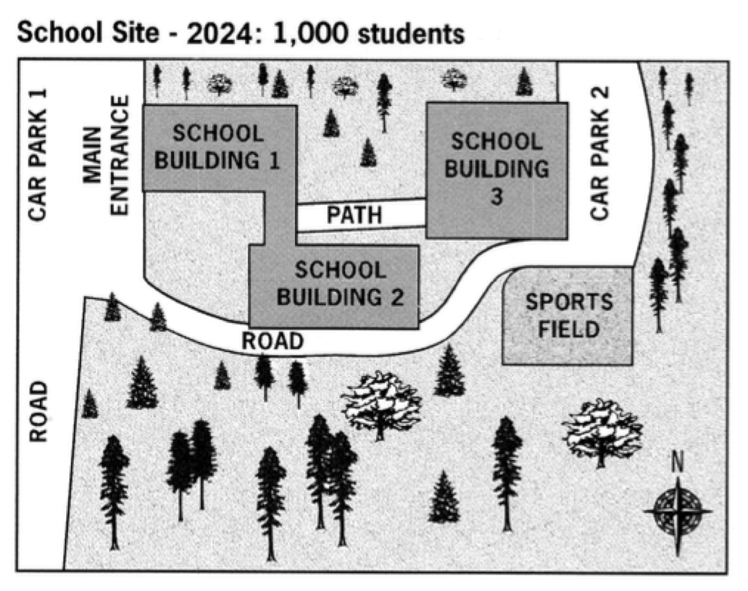
二. 按要求完成对应要点写作。
1. 用“东北角”描述main entrance

2. 用with结构描述school building 1，path和school building 2
- 用“不变”描述main entrance和car park

- 用“替换”描述school building 3和sports field

- 用“新增”描述car park 2和road

三. 请用英文单词的正确形式完成填空
The maps show the 1 ________ of a school site in 2004 and the same place in 2024.

Overall, although the layout will remain the same, there will be a number of changes, including the 2________ of sports field and the building of new 3________.

Back to 2004, when the school had 400 students in total, one could find the main entrance in the 4________ of the site, with a car park 5________. Entering the school, one could see school building 1 immediately, with school building 2 on the 6________ side. There was a path between the two buildings, and it led to a sports field in the 7________. The rest part of the area was covered by trees.

According to the plan, the school intends to recruit 600 more students, so there will be more buildings and facilities 8________ the campus. 9________ the entrance, car park and surrounding trees are expected to remain 10________, the school is going to add a third school building and another parking lot to 11________ the sports field which will in turn be 12________ in size and relocated towards the south. Because the old two buildings will be linked by a passage, the path is projected to be shorter. Additionally, 13________ the edge of the site, a new curved road will be 14________ to connect the two parking lots.

四. 根据上课内容，完成一篇小作文
You should spend about 20 minutes on this task.
The maps show the changes to the Shalton Village in 1910 and 2010.
Summarise the information by selecting and reporting the main features, and make comparisons where relevant.
Write at least 150 words.
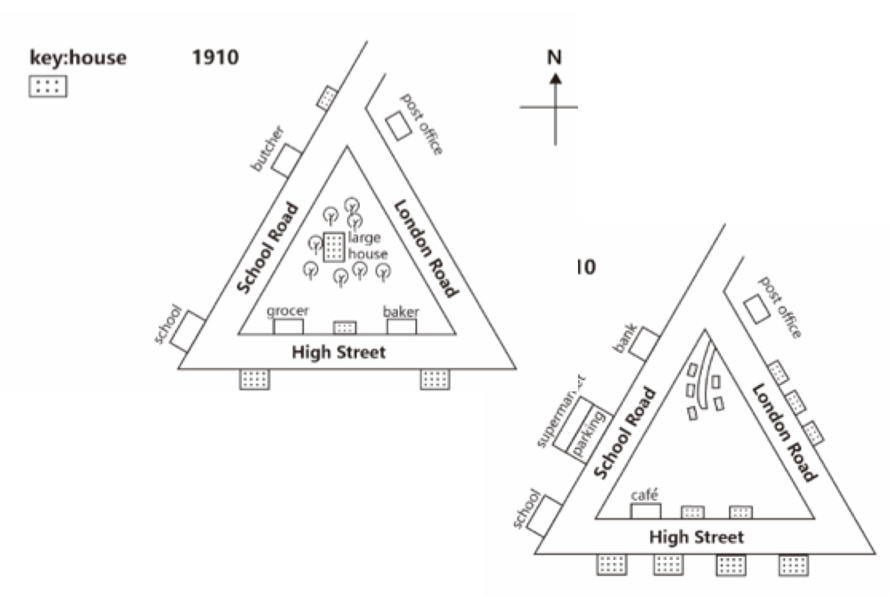
Answer Key:

一、
1. a school site; 一般过去，一般过去/过去完成
2.布局有发生变化，主要变化包括新建设施设备，sports field位移
3.按图分2段
4.主体段1：人数，main entrance + car park, school building 1 + 2, path, sports field, trees；主体段2: 人数增加，main entrance + car park + trees不变，新增school building 3和car park 2 + sports field位移，两个buildings联合 + path缩短，新增road

二、
详情可以看第三部分范文

三、
- layout
- relocation
- facilities
- northwest/top left
- nearby
- opposite
- northeast/top right
- on
- While
- Unchanged
- replace
- reduced
- along
- expected

四、
参考范文：
The maps show how the Shalton Village had changed since 1910.

Overall, it can be seen that the village had more places for people to live, entertain and work.
In 1910， there were eight trees and a large house right in the centre of the village. To the south of the trees there was a grocery store, a house as well as a bakery. They were all surrounded by School Road, London Road and High Street, forming a triangular shape. A post office was located near the junction of School Road and London Road. On the left-hand side of School Road were a house, a butcher’s shop and a school. Two more houses were built near the High Street.

By 2010, the village had changed considerably. The trees and the large house had been demolished to make way for several small houses, with a side road leading to these houses. On the right side of London Road and the bottom of the layout, more houses had been built. However, the house near School Road had been knocked down, while the butcher’s had been turned into a bank. Next to the bank, a supermarket was built, with a spacious parking in front of it. The establishments – the grocer’s and the bakery – had been replaced by a café and a house respectively. What remained unchanged were the school and the post office.

233 words

